***Data Requirements***

|  |  |  |  |  |  |
| --- | --- | --- | --- | --- | --- |
|  | **Data Item** | **Data Type** | **Validation** | **Sample data** | **Function of data item** |
| 1 | Username | String | = to value | WonderWalls | Stores the staff members username to access the system |
| 2 | Password | String | = to value | Admin1 | Stores the staff members password to access the system |
| 3 | Chose | integer | Is a digit and a valid choice | 1 | Allows member of staff to access different functions by entering in the function number |
| 4 | CompetitorNumber | String | N/A | WW3 | Stores a unique set of letters and numbers to easily identify competitors |
| 5 | FirstName | String | Is made of letters | James | Stores a competitor’s first name for use in identifying them or in reports |
| 6 | LastName | string | Is made of characters | Ross | Stores a competitor’s last name for use in identifying them or in reports |
| 7 | Postcode | string | The first 2 and last 2 characters are letters and the rest are digits | BT422DX | Stores a competitor’s postcode into the csv file which can be used as personal contact information |
| 8 | PhoneNumber | integer | Contains only digits and is a certain length | 07946119013 | Stores a competitor’s phone number into the csv file which can be used as personal contact information |
| 9 | Email | String | Has the correct address endings | Jrross@Hotmail.com | Stores a competitor’s email address into the csv file which can be used as personal contact information |
| 10 | Test 1 | float | N/A | 0.121 | Stores the first of a competitor’s 3 reaction time test to a csv file and can be used later in reports |
| 11 | Test 2 | float | N/A | 0.333 | Stores the second of a competitor’s 3 reaction time test to a csv file and can be used later in reports |
| 12 | Test 3 | float | N/A | 0.543 | Stores the third of a competitor’s 3 reaction time test to a csv file and can be used later in reports |
| 13 | Climb 1 | float | Is a digit | 12.1 | Stores the first of a competitor’s 3 climb times to a csv file and can be used later in reports |
| 14 | Climb 2 | float | Is a digit | 23.5 | Stores the second of a competitor’s 3 climb times to a csv file and can be used later in reports |
| 15 | Climb 3 | float | Is a digit | 50.2 | Stores the third of a competitor’s 3 climb times to a csv file and can be used later in reports |

***Inputs***

The user will be required to enter in a number of competitor details such as their first and last names and their postcode. This will be done by the system prompting them to input a certain piece of data which the will have space below to enter it in. The user will also have to input their username and password when logging onto the system which the system will also prompt them to enter in the data. 3 different reaction times will also be under took by the competitor these will consist of 3 short tests in which the user will have to press a certain letter or number. The user will be required to complete this as fast as possible and their average score of 3 attempts per test will be shown to the competitor before being stored.

***Storage***

All competitor details will be stored into a single csv file by the system. This allows the system to use this information stored in the file to generate reports based on that information and identify and use an individual competitor’s details. The information that is stored in the csv file is the competitor’s:

* First Name
* Last Name
* Competitor Number
* Postcode
* Phone Number
* Email Address
* 3 Separate Climb Times

The competitor will also have their 3 separate reaction time scores recorded in the csv file along with the rest of their details. The 3 times are as follows:

* Press Enter When A Word Appears
* Press Enter When A Particular Number Appears In A Sequence
* Enter In A Series Of Characters

***Outputs***

*Reports*

The system will also produce a summary report of each competitor’s data which consists of a summary of their name, competitor number and results from both their reaction time tests and climb times.

Another report is a leader board produced from a score from both the reaction times and the climb times. This is an overall score and the top will be the person with the highest and the bottom will be the person with the lowest.

Another report will create a leader board that is based solely on the results of the reaction time tests and will therefore be a reaction test leader board

Similarly, the final report will be based on the results of the climbs and will not include the reaction time test. This allows competitors to see where they place in individual sections of the competition.

Need to add navigation drawings

***Designing Algorithms***

*Success Criteria*

1. Logging On
2. Menu System
3. Assigning An Auto Number
4. Add Competitor
5. Reaction Time Tests
6. Reports
7. Entering in climb times

*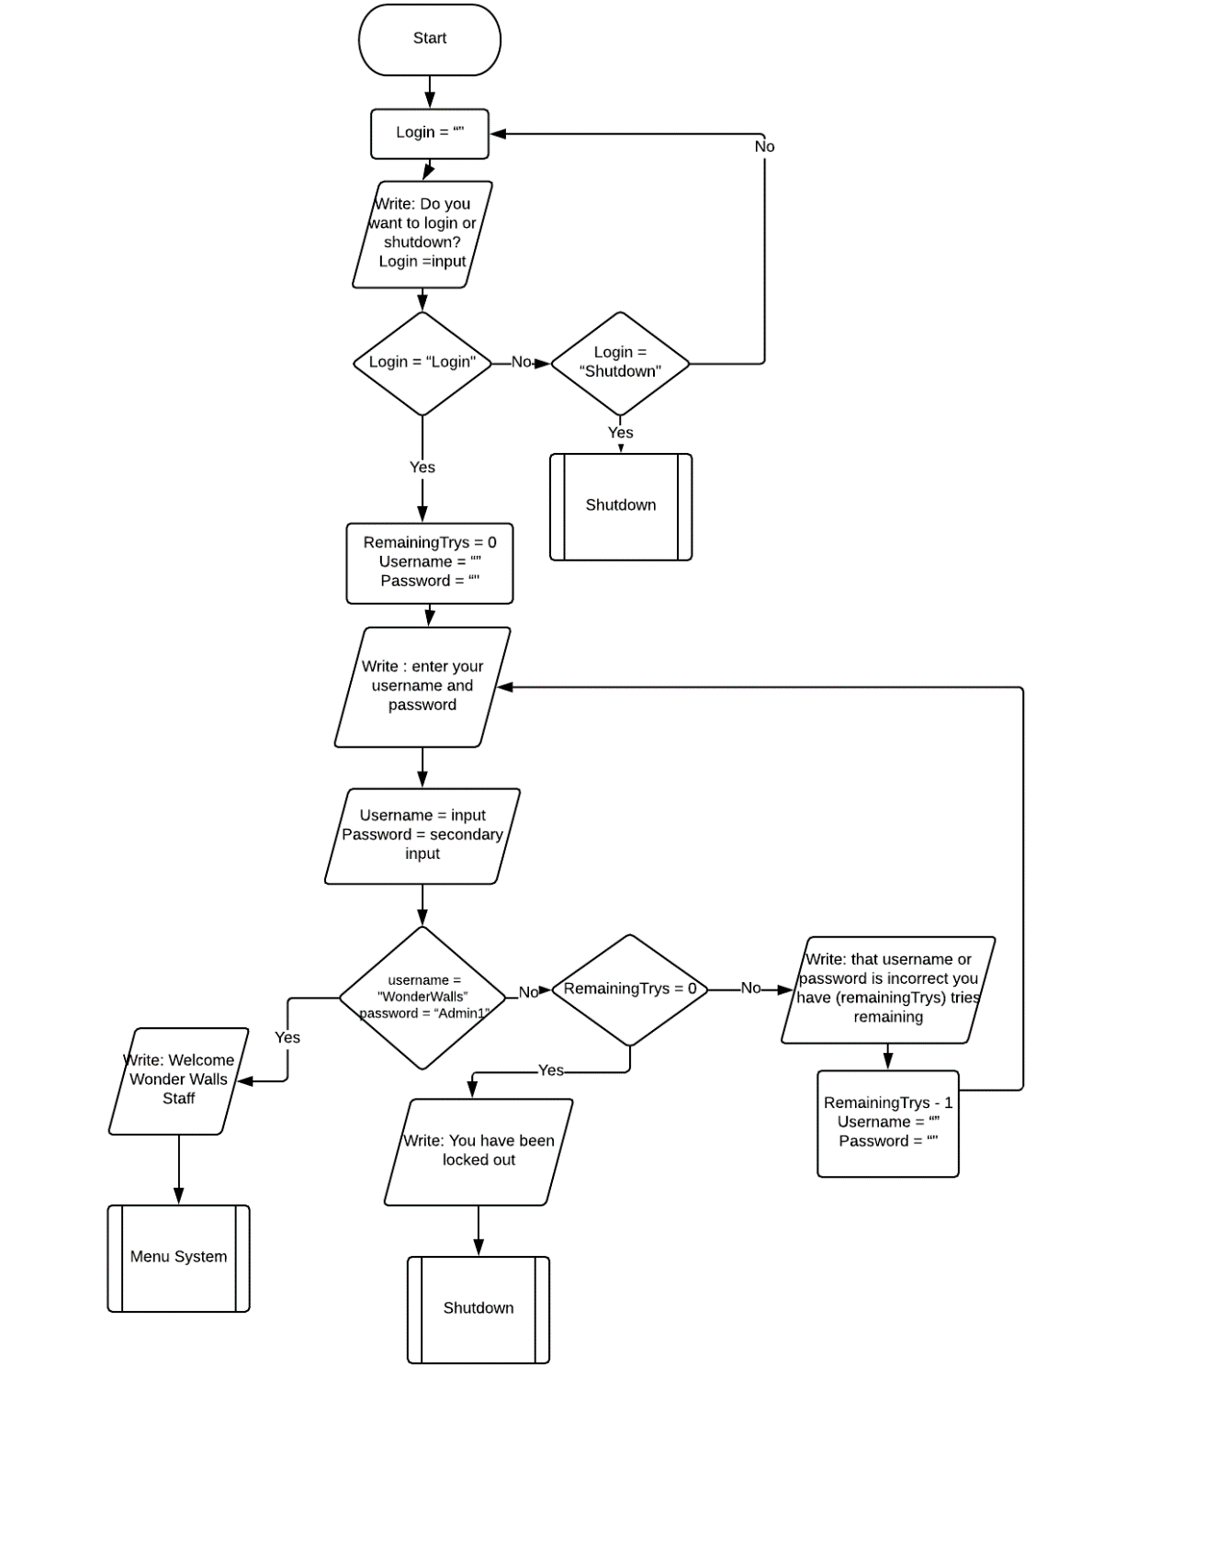Logging on:*

*Menu System:*

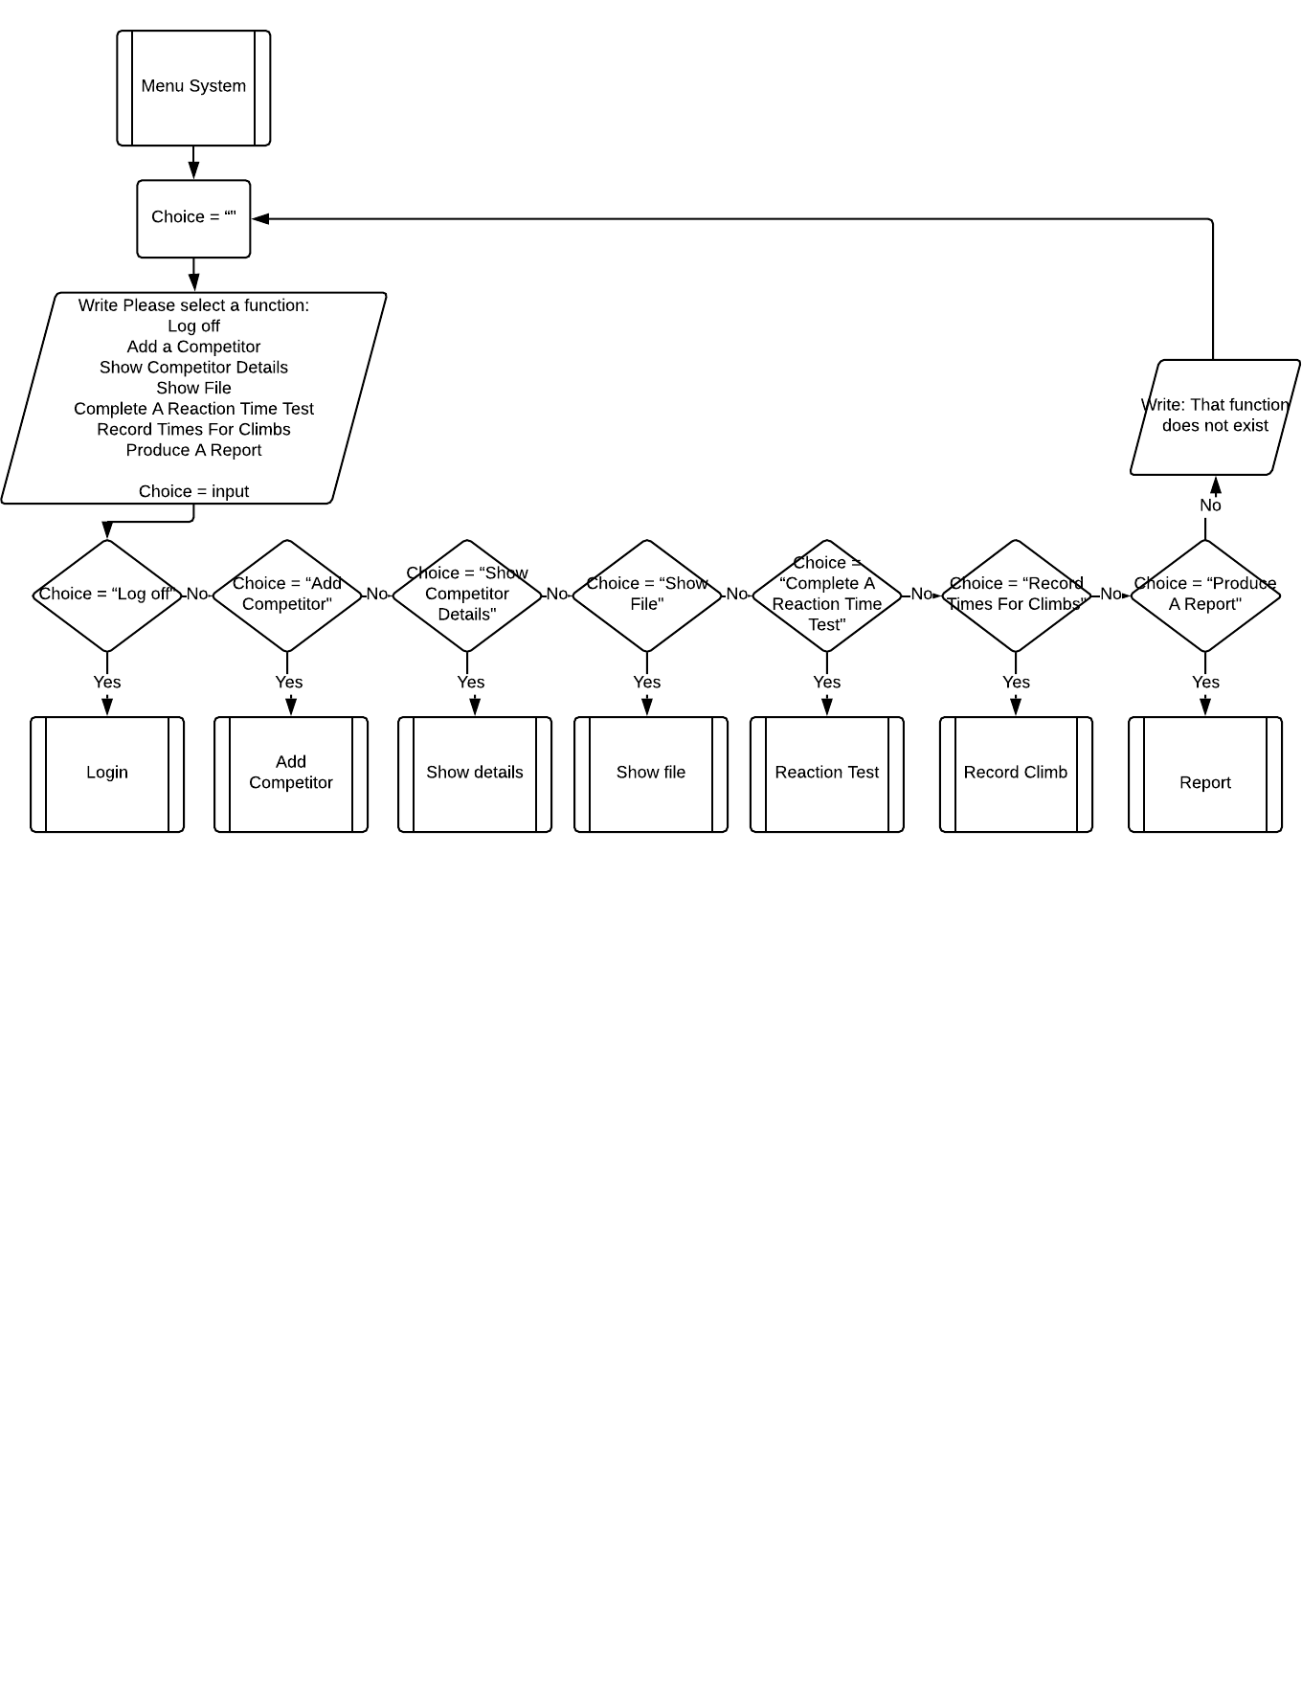

*Assigning An Auto Number:*

file = open("Customer Details.csv", "r")

text = read file

length =read number of lines in file

customerNum = length

with open("Customer Details.csv", "a") as csvWrite:

csvWrite.write to file(CustomerNum)

*Add Competitor:*

firstName = input("To add a competitor please enter their first name: ")

lastName = input("please enter their Last name: ")

postcode = input("please enter their postcode: ")

email = input("please enter their email address: ")

phone = Input("please enter their phone number: ")

Details = [firstName, lastName, postcode. Email. Phone]

with open("Customer Details.csv", "a") as csvWrite:

csvWrite.write to file(Details)

*reaction Time Tests:*

*still to add*

*Reports:*

*still to add*

*entering in climb times:*

*still to add*